Company Names (who is conducting the work) |  | ABN
Job Description | Install plasterboard (ceilings and walls) on stilts | Date
Procedure |  | Project
ABN |  | Site Supervisor Name and Phone Number
Workers consulted about SWMS |  | Number of workers involved in activity

High Risk Construction Work | ☒Risk of a person falling more than 2 metres (Note: in some jurisdictions this is 3 metres) | ☐ Work on a telecommunication tower | ☐Demolition of load-bearing structure
High Risk Construction Work | ☐ Work in or near a shaft or trench deeper than 1.5 m or a tunnel | ☐Use of explosives | ☐Work on or near pressurised gas mains or piping
High Risk Construction Work | ☐ Work on or near chemical, fuel or refrigerant lines | ☐ Work on or near energised electrical installations or services | ☐Work in an area that may have a contaminated or flammable atmosphere
High Risk Construction Work | ☐Tilt-up or precast concrete elements | ☐ Work on, in or adjacent to a road, railway, shipping lane or other traffic corridor in use by traffic other than pedestrians | ☐ Work in an area with movement of powered mobile plant
High Risk Construction Work | ☐ Work in areas with artificial extremes of temperature | ☐ Work in or near water or other liquid that involves a risk of drowning | ☐Diving work

SWMS prepared by | Position: | Signature | Date
SWMS is prepared in consultation with (add names)
What measures are in place to ensure compliance with the SWMS? | General induction, company induction, SWMS induction, prestart and supervision | Date SWMS provided to the PC
SWMS will be reviewed | 6 Month from the date
Who ensures all work is in accordance with SWMS (must include their name) | - Supervisor  - Director  - HSEQ  - Other -specify | Methods to ensure compliance | - Supervision  - Surveillance Inspections  - Audit

Selecting Risk Controls  Any risk to health or safety must be eliminated, or if that is not reasonably practicable, reduced so far as it reasonably practicable by | 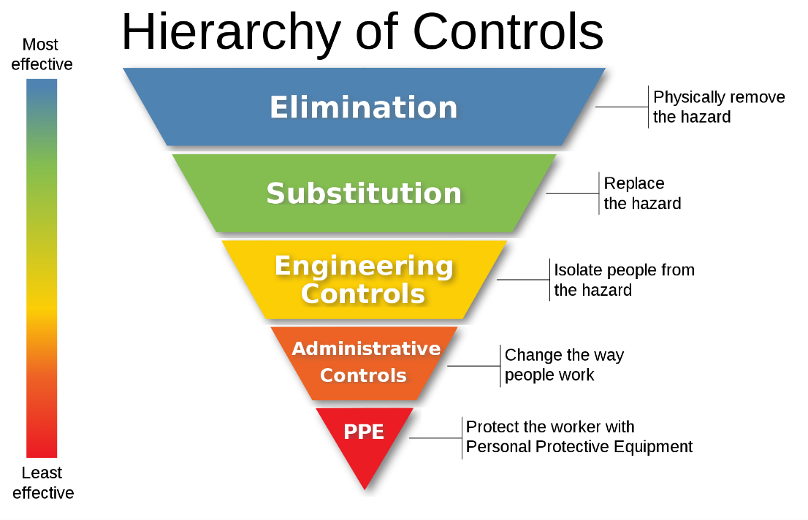 | • Implementing any mandated controls specified by law.  • Substituting a new activity, procedure, plant, process or substance (e.g. scaffold in preference to ladders).  • Isolating persons from the hazard (e.g. fence off areas for mobile plant operation).  • Using engineering controls (e.g. guard rails, trench shields) - or a combination of the above.  If any risk to health or safety remains, it must be reduced by using:  • Administration controls (e.g. activity specific safety training, work instructions, warning signs).  • PPE such as respiratory protection, hardhats, high visibility clothing - or a combination of the above.

Work Safety Analysis
Legal Requirements
Legal Requirements | - Work Health & Safety Act 2011  - Work Health & Safety Regulations 2017
Codes of Practice | - Confined Spaces  - Hazardous Manual Tasks  - How to manage and control asbestos in the workplace  - First Aid  - Excavation Work  - Construction Work  - How to Manage Work Health and Safety Risks  - Labelling of Workplace Hazardous Chemicals  - Managing Noise & Preventing Hearing Loss at Work | - Managing the Risk of Falls at Workplaces  - Managing the Work Environment & Facilities  - Work Health & Safety Consultation, Co operation and Co ordination  - Managing Electrical Risks  - Working in the vicinity of Overhead & Underground Electrical Lines  - Safety Guide1419 Working near underground assets. 2007  - Work Near Overhead Power Lines 2006

Risk assessment
 | Risk Assessment Matrix
 | Consequence
Likelihood | Minor  Near miss of minor injury  Requires localized clean up  Customer complaint | Moderate  Significant non-permanent injury/illness requiring hospitalisation more than 7 days  Environmental damage  Rework | Major  Fatality or permanent injury  Significant environmental damage  Major rework
Almost Certain | Medium | High | High
Possible | Low | Medium | High
Unlikely | Low | Low | Medium

ITEM | SEQUENCE OF BASIC JOB STEPS | POTENTIAL HAZARDS | RISK | CONTROL MEASURES | Control Hierarchy | Responsible Person | RISK
1 | Assess General Working conditions | Slip Trips and Falls | Med | Inspect site prior to starting work to identify trip, slip, fall hazard.  If possible:  - Remove slip, trip and/or fall hazard from site.  - Barricade hazard.  - Report location of hazard and record in toolbox meeting to notify other parties,  - Wear PPE boots, safety glasses. | PPE  Eliminate  Isolate  Admin  PPE | All workers | Low
 |  | Hazards due to lower visibility associated with no light or night works. | High | - Try to schedule work to occur during normal working hours.  - Ask customers to organise further safety measures to minimize risk, such as:  - Appropriate Lighting (e.g. day makers  - Follow the Fitness for Work Policy (see next point)  - Appropriate PPE: including task lighting  - High Visibility Reflective clothing and vests (refer to SWMS cover sheet).  - Small Miners type light on headwear. | Admin  Engineering  Admin  PPE | All workers | Very Low
 |  | Housekeeping | Med | - Ensure all areas are clear and free of trip hazards  - Prepare all items before work commences | Eliminate | All workers | Very Low
2 | Attach silts | Silts are not stable – Fall | High | - Find a raised surface (chair) to fit the traps (with 90-degree bend in knee and the stilt vertical) Strap silts to foot and leg  - All straps must be secured  - Replace missing straps  - Never use silts with missing or damaged straps  - Shoes and boots must be fitted securely  - Fit foot straps over boot or show securely  - Fit leg straps around pants – the semi-circle knee brace sits below the knee (some have height adjustable knee supports)  - All straps must be as tight and secure as possible | PPE | All workers | Very Low
 | Stand on stilts | Unable to stand on Stilts (fall) | High | - If the surface is high enough worker may stand  - Ensure there is a safe means of attaching and removing stilts. A rigid platform should be used for mounting and dismounting stilts with the platform at a height equal to or greater than the height of the stilts. Do not use stepladders. | PPE | All workers | Very Low
 |  |  |  | - All equipment and materials required by a stilt worker should be at a height to prevent them over-reaching or bending down below knee level. Or Tools and materials can be passed up to the stilt worker by another person standing on the floor.  - The stilt worker's torso should be vertical whenever possible and tasks that require frequent bending should be avoided.  - Do not jump while wearing stilts.  - Do not handle long, heavy or cumbersome objects  - No other workers should be in the area used by stilt workers unless they are assisting the stilt worker. If this cannot be guaranteed, the work area should be taped off or barricaded to prevent access.  - Any waste or material dropped by stilt workers should be cleared away by an assistant | PPE | All workers | Very Low
 |  |  |  | - Supervisors should regularly check that stilt workers are not experiencing fatigue.  - Any one period of working on stilts should be not greater than two hours. With at least thirty minutes of non-stilt tasks and should not be used by any individual for more than six hours per day.  - The springs should not be fully compressed by lifting heavy objects or exerting high upward force, such as drilling through overhead structures. | PPE | All workers | Very Low
 | Work at height -voids and penetrations stairwells | Fall through void | High | - Areas near voids, stairwells should be avoided  - There should be no unmarked penetrations  - Voids and penetrations should be fenced, or covered to avoid accidental stepping or falling into  - Where covered the SWL of the cover should be clearly visible  - Where fenced or barriers these should sustain an impact of 80kg or more without failure | Engineer | All workers | Medium
 | Emergency procedure | Workers left behind in the event of an evacuation |  | - Emergency procedures need to be detailed on how stilt workers are to evacuate. | PPE | All workers | Very Low
Other –
Site Specific task and associated hazard not already in this SWMS
(amend as required, use back page if req’d)

Gear and equipment Maintenance
Plant Used | Maintenance checks | By Whom | Frequency
Equipment Used | Maintenance checks | By Whom | Frequency
Stilts | Check all straps are present and not damaged | Worker using stilts | Visual before use

Training
Trade qualifications relevant to the work and have completed training courses available to construction
Qualification | Name | Name | Name | Name | Name
Formal qualifications
Years’ Experience
Driver’s License
Safe Work General Construction Induction
First Aid
Cert IV Plasters
Enrolled in apprenticeship
Other (specify)

SWMS Induction and Sign on
CONSULTATION: I have been given the opportunity to discuss the hazards that exist for this activity and provide input into the safety controls that are to be implemented to control those hazards. I have had adequate instruction in the handling, storage and use of the chemicals and fibre-based products to be used during this operation and have access to the relevant Material Safety Data sheet (MSDS) for each. I have now been inducted into this Safe Work Method Statement (SWMS) for this Project and understand the hazards, risks and control measures to be implemented for the safe completion of the job
Name | Signature | Company | Date | Name | Signature | Company | Date

